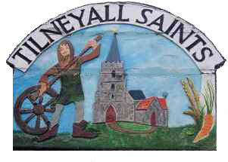
TILNEY ALL SAINTS PARISH COUNCIL

Community Award Scheme Nomination Form

In February 2022 Tilney All Saints Parish Council agreed to set up an annual award scheme to recognise the achievements of residents who have contributed and made a difference to the Tilney All Saints community or have improved or brought credit to the Parish. The contribution to the community could be historic or ongoing.
This is an annual award, either to one individual or to a local community group.

There are no deadlines for receiving nominations.
Nominations will be considered by Councillors throughout the year (April to April) with a final decision made at the Parish Council meeting held in March each year.

Please complete the nomination form below and return to the Parish Clerk either via email clerk@tilneyallsaintsparishcouncil.gov.uk
Or by post to:
234 Smeeth Road, Marshland St James, Wisbech, Cambridgeshire, PE14 8ES

Name of the resident or local community group to be nominated:

Name and contact details of person proposing the nomination:

Your Name:

Your Address:

Your Tel. No.:

Your Email:

Please tell us your reasons for making this nomination, providing as much detail as you can about the individual / organisation, their activities, and why you feel they deserve to be recognised:

DECLARATION
I declare that the individual / local community group I have nominated is not aware of this nomination and that, to the best of my knowledge, the reasons for this nomination and the information I have provided are true and correct.

Signed:

Print name:

Date:

Your privacy is important to us, and we will only keep your information for the purposes for which it was submitted.
You can find out more about how we use your data from the Privacy Notice available on our website

